Call for papers for a symposium on
*
Critical Approaches to the Spatial Dimension of Social Relations:
Transdisciplinary and Transnational Debates

Organized by the ESO mixed research unit (Espaces et Sociétés – Spaces and Societies) and JEDI (Justice, Espace, Discriminations, Inégalités – Justice, Space, Discriminations, Inequalities), a transversal group of LabEx Futurs Urbains (Urban Futures Laboratory of Excellence, University of Paris-Est)
Caen (France), 26–28 June 2019
The starting point for this symposium is the recent exposure and dynamics of critical approaches to social relations in geography in France, bearing in mind that analyses focusing on inequalities and relations of power and domination have long been essential considerations in English-language geography and, of course, in sociology. And yet the other social sciences do not always take account of the spatial dimension of these questions, which is why this symposium seeks to open up a space of transdisciplinary and transnational dialogue.

Context and objectives
Since the mid-2000s, the question of the spatial dimension of social relations, and more specifically of social inequalities and of relations of power or domination, seems to have become more and more present in French geography. This is evidenced by the growing number of seminars, symposiums, and individual and collective publications that focus on questions such as the appropriation of space, spatial justice, gentrification and territorial discrimination. This is not just an innovation, but without doubt also a new threshold in terms of the implementation, visibility and structuring of these orientations – which we shall describe as “critical” for purposes of simplicity and to use an increasingly common label. There are indeed multiple filiations which combine endogenous dynamics in French geography with the import of approaches encountered in other social sciences or other geographies – English-language geography in particular – all of which are inseparable from their social, economic and, above all, political contexts.
No doubt because of social movements that once again became important in France in the 1990s and 2000s (e.g. the large-scale strikes of 1995; the mouvements des « sans », or movements of the “withouts”, such as the undocumented, the homeless, and the jobless; alter-globalization movements), the explosion of socioeconomic inequalities, and the international financial crisis of 2007–2008, the French social sciences have seen a “return of social class” to a certain degree. In French geography, this analytical entry point had been the preserve of the promoters of social geography in the 1980s. It has recently experienced a revival of interest in English-language radical geography, in particular with the many translations of David Harvey’s works and an increased focus on issues such as gentrification and the neoliberal city. It is also in the English-speaking world that researchers, some of them from the field of cultural geography, have brought to the fore other inequalities, discriminations or relations of domination that have so far been rarely explored in French geography, relating to sex/gender, sexuality, and “race” in particular. Although older works, particularly feminist ones, already existed in the other social sciences in French-speaking academia, a similar import of gender studies, and subsequently postcolonial and subaltern studies, took place at about the same time and resonated with certain recent causes (parity, civil partnerships and “marriage for all”, “riots in the banlieues” in 2005, “positive aspects of colonization”, the “Islamic scarf controversy”, etc.). Moreover, while analysis of the intersectionality, intertwining and consubstantiality of these different inequalities and relations of domination has been on the agenda for more than a decade in the French-language social sciences, its development is still limited in the field of geography.
In parallel, space or the spatial dimension of social relations has begun to be integrated more broadly into analyses in the other social sciences (sociology, political science, history, etc.), but not always in an explicit and systematic way. Leaving aside certain long-standing specialities, such as urban sociology, the “spatial turn” evoked by Edward Soja in 1989 is only now beginning to correspond to a certain reality in France, through debates on “globalization” and other “turns” that these debates seem to have created, namely around issues of mobility or circulation, with “global” and “transnational” studies. These emerging subjects – perhaps a specificity of the French academic sphere – do not necessarily translate to a greater consideration of the work of geographers, even though geography is a discipline that, relatively speaking, is more institutionalized and present in France than in other countries. Above all, though, they do not always coincide with a critical turning point… Nevertheless, the number of analyses of relations of domination that, de facto, take account of their spatial dimension seems to be growing – for example, by questioning the effects of scale in critical sociology, through initial research into the spatial dimension of social movements, or through different works that call upon the work of Henri Lefebvre and his heterodox Marxism – especially as 2018 marks 50 years of Right to the City, celebrated in numerous events.
This symposium seeks to extend these collective dynamics and aims not just to strengthen them but also to bring them into convergence by creating a time and space for meetings and for transnational and transdisciplinary discussions: between the various French-language critical geographies; between these geographies and those of other national or international fields (English-language in particular); and between the critical approaches of various social sciences that seek a more in-depth analysis of the spatial dimension. This debate is necessary because the researchers who lead and inform it have not all followed the same educational and intellectual trajectories, do not necessarily make use of the same references or tools, may not adopt the same approaches, and are far from always being in agreement. It is therefore important to put all the different options on the table and discuss them, in order to take stock of the current state of affairs, facilitate mutual acculturations, identify points of agreement and sticking points, and advance thinking on the subjects under consideration. How should we go about analysing the spatial dimension of inequalities and relations of domination and the ways in which they are interconnected? On what kinds of basis can different critical approaches converge? What differences exist from one national context to another, from one discipline to another, from one generation to another, etc.? What are their strengths and weaknesses? What tensions can be observed? What should we be focusing on in the coming years?

Lines of thinking
The choice has been made not to organize specific thematic sessions defined in advance, so as not to exclude anybody a priori and to allow for a maximum of transversal exchanges between researchers working on different subjects. The symposium will therefore include empirical proposals both on “classic” subjects, or subjects already established within the landscape of critical approaches (residential segregation, migration, effects of neoliberalism, etc.), and on issues that are still poorly addressed, particularly in France, or which need to be taken on board as a matter of urgency in light of current political developments, all of which constitute new frontiers that we feel it is essential to address: environmental and ecological inequalities (environmental cultural studies, political ecology); transformations in the education system and the world of work; police and penal institutions; the uses of digital technology; the situation of minorities; collective mobilizations; etc. Finally, it should be specified that while these subjects are to be studied and developed in terms of the spatial dimension of social relations, from urban centres to rural zones, in both the Global North and the Global South, it is not necessary to cover all forms of inequality, discrimination and domination (class, sex/gender, “race”, sexuality, age, disability, etc.) in order to participate. Depending on the responses we receive to this call for papers, several types of sessions are envisaged, the scope and content of which may intersect:
- Epistemological sessions devoted to historical overviews or more specific studies of different critical approaches, their orientations and their relations in different disciplines, as well as in different countries. What are the routes taken by these approaches and those who promote them? Can we identify effects of disciplinary or national (or even local) contexts that shed light on their characteristics? Under what conditions, by what trajectories and with what effects do transdisciplinary and transnational circulations – of labels, concepts, theories, references, methods, etc. – take place? What are the effects of dominations between countries (and languages) or between disciplines? What is the place of geography and works on the spatial dimension of the social domain in the various national, disciplinary and thematic fields?
- Theoretical sessions on participants’ different positions, in which the concepts, approaches and preferred references will be presented and discussed. What concepts can be used to analyse different types of inequalities and relations of domination? What is the relevance and what are the limitations of the concepts of class, sex/gender, “race”, sexuality, etc.? How can they be interconnected, and using which theoretical approach? To what extent are the major approaches of the 20th century (Marxism, structuralism, feminism, queer theory, postcolonial studies, subaltern studies, post-structuralism, etc.) and the “big names” of social theory (Bourdieu, Butler, Delphy, Foucault, Lefebvre, Said, Scott, etc.) still relevant today? How can the spatial dimension be integrated into these analyses, even though these authors (and others) do not usually do so themselves? Should we talk about “spatial” or “territorial” inequalities or injustices alongside the inequalities of class, sex/gender, “race”, etc., or is space a dimension of each social relation, as well as of their interconnection? And how should the effects of contexts – not just historical but also geographical – be taken into consideration?
- Methodological sessions devoted to the survey techniques implemented and, more generally, to the research approaches or strategies adopted, in particular when considered in terms of critical approaches. This will involve demonstrating, with the aid of example surveys, the benefits and limitations of different methodological options, whether well established or innovative (cartography; possible uses of online resources, video, photography, documentary films; etc.). It will also involve obtaining some perspective and distance regarding the practices used and their stakes. Can we identify methodological characteristics specific to certain specialities, theoretical currents, disciplines or national contexts? Should we maintain, move beyond or create links between them, as in the case of the long-standing opposition between “quantitative” and “qualitative” methods? What are the implications of the spatial dimension of a given method (particularly in relation to claims of generalizability)? What are the effects, advantages and difficulties of collective research (bearing in mind that collective groups seem increasingly to bring together members of different disciplines, from different countries, speaking different languages, as well as people who are not research professionals)? And what domination effects are at play within these collectives?
- Sessions on researchers’ forms of engagement or involvement, ethical and political postures, and various relationships with the social world. While it is clear that every researcher is involved in the social world in one way or another, and not only those who claim to be politically engaged or activists, are there specific forms of involvement related to critical approaches? Does this question only concern the potential effects of the dissemination of work, or does it permeate the whole research process (definition of the method, fieldwork, writing up, etc.)? For example, what do “participatory” approaches for the “co-construction of knowledge” with respondents involve, and what can be done in this case when working with people in a dominant position? How should we deal with the forms of domination that exist within any group or collective surveyed, even when it is dominated or militant for a cause that we share? In particular, what relationships of domination can come into play between researchers and activists? What stance should researchers adopt in relation to activist categories – for example, those that have been produced by feminist movements, such as intersectionality? Does including the spatial dimension necessarily mean focusing on “local” struggles and/or the appropriation of space? The question of involvement also arises within the academic field, in our relations with the categories produced by national and international institutions and by research (counter-)reforms: what effects and reactions exist, and what strategies should be adopted?
- In connection with the above, sessions on teaching and more generally practices and forms of disseminating/passing on of knowledge both within and outside university contexts. Many researchers are also teachers, especially at university. Should we not therefore question the possibility of being a “critical teacher”, and what this means and implies? Can this be summed up as simply passing on knowledge considered critical, without questioning the forms of transmission and inequalities that exist in the education system? And how can these questions be addressed without responding to the injunctions of university institutions? Towards what forms of “alternative”, “critical”, “emancipatory” or even “intersectional” pedagogy should we turn? What conclusions can be drawn regarding the success of “people’s universities”, outreach programmes “beyond campus walls”, and popular education movements? And what relationships can be forged with these movements?

Organizational and scheduling details
This symposium will not take the form of a conference with a multitude of parallel sessions and workshops. The aim is to encourage moments of exchange and discussion, and to foster the broadest possible debates, using round-table formats, in plenary or “semi-plenary” sessions. For this reason, and in order to promote dialogue between speakers of different languages, we expect to receive papers in advance, so that they can be distributed to participants on the one hand, and to facilitate the preparation of future collective publications on the other. Similarly, during the symposium, oral presentations of the papers can be made in French, English or Spanish.
Proposals for papers should include: a title, a summary (between 3,000 and 5,000 characters, or approximately 500 to 800 words) and, if desired, a proposal for inclusion in a particular type of session. We expect to receive two separate files: one should be anonymous; the other should include the name(s) and institution(s) of the author(s) at the beginning. Once a proposal has been accepted, the final paper must be between 30,000 and 50,000 characters (approximately 5,000 and 8,000 words) in length. Collective publications following the symposium are envisaged, in the form of a book or special issues of journals.
Proposals for contributions and papers should be sent to <jean.riviere@univ-nantes.fr> in accordance with the following schedule:
- 15 November 2018: deadline for proposals for contributions;
- 15 January 2019: announcement of the scientific committee’s decisions;
- 1 May 2019: deadline for final papers.

Scientific committee and organizing committee

Organizing committee
Pierre Bergel (geographer, University of Caen Normandy, ESO), Karine Breton (administrative manager, Rennes-2 University, ESO), Anne Clerval (geographer, University of Paris-Est Marne-la-Vallée, ACP), Cyril Darthenay (secretary/supervisor, University of Caen Normandy, ESO), Camille Devaux (geographer, University of Caen Normandy, ESO), Emmanuelle Hellier (urban planning and development, Rennes-2 University, ESO), Maxime Marie (geographer, University of Caen Normandy, ESO), Xavier Michel (geographer, University of Caen Normandy, ESO), Fabrice Ripoll (geographer, University of Paris-Est Créteil, Lab’Urba), Jean Rivière (geographer, University of Nantes, ESO), Mathieu Uhel (geographer, University of Caen Normandy, ESO).

Scientific committee
Chadia Arab (geographer, CNRS ESO, Angers), Guy Baeten (geographer, Malmö University), Thomas Bassett (geographer, University of Illinois Urbana–Champaign), Nuria Benach (geographer, University of Barcelona), Sophie Blanchard (geographer, University of Paris-Est Créteil, Lab’Urba), Florence Bouillon (socioanthropologist, Paris-8 University Vincennes–Saint-Denis, LAVUE–AUS), Rachele Borghi (geographer, Sorbonne University, ENeC), Sébastien Caillault (geographer, Agrocampus Angers, ESO), Christine Chivallon (geographer and anthropologist, University of Bordeaux, PASSAGES), Fabien Desage (political scientist, University of Lille, CERAPS), Muriel Froment-Meurice (geographer, Paris-Nanterre University, LAVUE–Mosaïques), Leïla Frouillou (geographer and sociologist, Paris-Nanterre University, GTM–CRESPPA), Fanny Gallot (historian, ESPE Créteil, CRHEC), Camille Gardesse (sociologist, University of Paris-Est Créteil, Lab’Urba), Ève Gardien (sociologist, Rennes-2 University, ESO), Séverin Guillard (geographer, University of Paris-Est Créteil, Lab’Urba), Claire Hancock (geographer, University of Paris-Est Créteil, Lab’Urba), Myriam Houssay-Holzschuch (geographer, Grenoble-Alpes University, PACTE), Veronica Ibarra (geographer, National Autonomous University of Mexico), Violaine Jolivet (geographer, Université de Montréal), Régis Keerle (geographer, Rennes-2 University, ESO), Stefan Kipfer (political scientist, York University, Toronto), Joanne Le Bars (geographer, University of Paris-Est Marne-la-Vallée, ACP), Julian Mischi (sociologist, INRA Dijon, CESAER), Sophie Moreau (geographer, University of Paris-Est Marne-la-Vallée, ACP), Marie Morelle (geographer, Paris-1 University Panthéon–Sorbonne, Prodig), Nasima Moujoud (anthropologist, Université Grenoble Alpes, LARHRA), Mari Oiry-Varacca (geographer, University of Paris-Est Marne-la-Vallée, ACP), Anne-Laure Pailloux (geographer, University of Paris-Est Créteil, Lab’Urba), Julien Rebotier (geographer, CNRS Toulouse, LISST), Sylvie Tissot (sociologist, Paris-8 University Vincennes–Saint-Denis, CRESPPA–CSU), Mathieu Van Criekingen (geographer, Université Libre de Bruxelles, LIEU), Vincent Veschambre (geographer, ENSA Lyon, EVS–LAURE, RIZE), Étienne Walker (geographer, University of Caen Normandy, ESO), Serge Weber (geographer, University of Paris-Est Marne-la-Vallée, ACP).
***
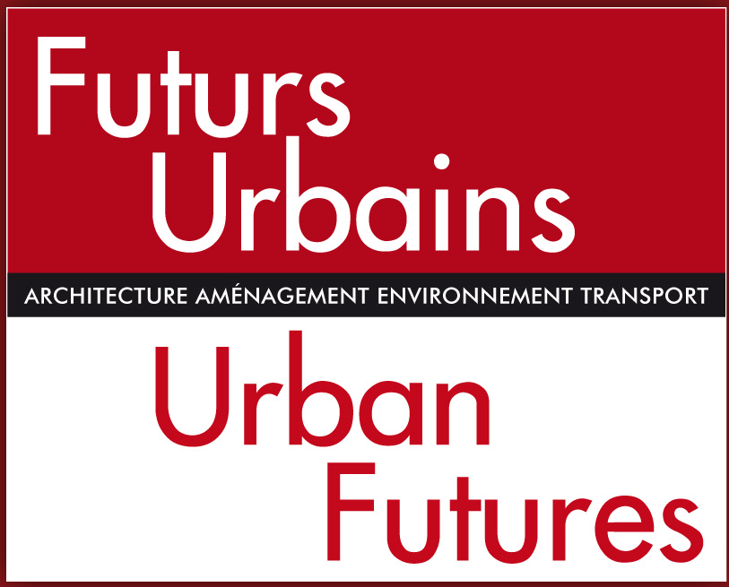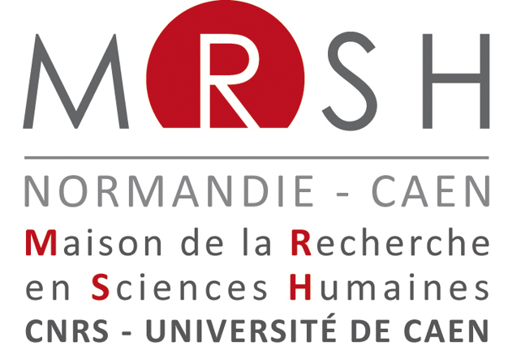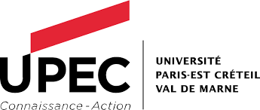

For more on the main French theoretical lineage of this symposium,we invite you to consult the following works published since the mid-2000s: Norois, 2005, no. 195: “L’appropriation de l’espace. Sur la dimension spatiale des inégalités sociales et des rapports de pouvoir”, coordinated by Fabrice RIPOLL and Vincent VESCHAMBRE; Annales de Géographie, 2009, nos. 665–666: “Justice spatiale”, edited by Philippe GERVAIS-LAMBONY; BRET Bernard, GERVAIS-LAMBONY Philippe, HANCOCK Claire, and LANDY Frédéric (eds.), 2010, Justice et injustices spatiales, Presses Universitaires de Paris-Ouest, Nanterre, 315 pp.; Regards sociologiques, 2010, no. 40: “Mobilité/autochtonie : sur la dimension spatiale des ressources sociales”, coordinated by Fabrice RIPOLL and Sylvie TISSOT; BACKOUCHE Isabelle, RIPOLL Fabrice, TISSOT Sylvie, and VESCHAMBRE Vincent (eds.), 2011, La Dimension spatiale des inégalités. Regards croisés des sciences sociales, Presses Universitares de Rennes, Rennes, 357 pp.; BLANCHON David, GARDIN Jean, and MOREAU Sophie (eds.), 2011, Justice et injustices environnementales, Presses Universitaires de Paris-Ouest, Nanterre, 233 pp.; BONNY Yves, OLLITRAULT Sylvie, KEERLE Régis, and LE CARO Yvon (eds.), 2012, Espaces de vie, espaces enjeux. Entre investissements ordinaires et mobilisations politiques, Presses Universitaires de Rennes, Rennes, 408 pp.; Carnets de géographes, 2012, no. 4: “Géographies critiques”, coordinated by Yann CALBÉRAC and Marianne MORANGE; CLERVAL Anne, FLEURY Antoine, REBOTIER Julien, and WEBER Serge (eds.), 2015, Espace et rapports de domination, Presses Universitaires de Rennes, Rennes, 399 pp.; HANCOCK Claire, LELÉVRIER Christine, RIPOLL Fabrice, and WEBER Serge (eds.), 2016, Discriminations territoriales. Entre interpellation politique et sentiment d’injustice des habitants, L’Œil d’Or, Paris, 271 pp.; BONNY Yves, BAUTÈS Nicolas, and GOUËSET Vincent (eds.), 2017, L’Espace en partage. Approche interdisciplinaire de la dimension spatiale des rapports sociaux, Presses Universitaires de Rennes, Rennes, 360 pp.; Carnets de géographes, 2017, no. 10: “Pour une réflexion collective sur l’enseignement de la géographie à l’Université”, coordinated by Jean GARDIN, Marie MORELLE, and Fabrice RIPOLL.
Many of the terms of this call for papers would, under normal circumstances, benefit from being explicitly defined, but it is precisely because questions of definition are the subject of theoretical debate that the organizing team of this symposium has chosen not to restrict the debate by specifying the meanings of words from the outset. Conversely, these terms could have been put in quotes to signal this lack of bias regarding the labels employed, but we have chosen to limit the use of quotation marks for ease of reading.
Recently expanded to “urban and territorial sociology”, according to the title of the thematic network of the AFS (Association Française de Sociologie – French Association of Sociology).
For example: “Cinquante ans après Le Droit à la ville: quelle actualité ?” (Tours, March 2018); “Henri Lefebvre, Le Droit à la ville (1968–2018). Rencontres internationales” (Paris, April 2018); “Le droit à Lefebvre” (Caen, June 2018).
The organizing committee welcomes alternative forms of communication with interest: conferences with sign-language interpretation, forum theatre, performances, etc.

